DATA/CS 172 – Lab 13
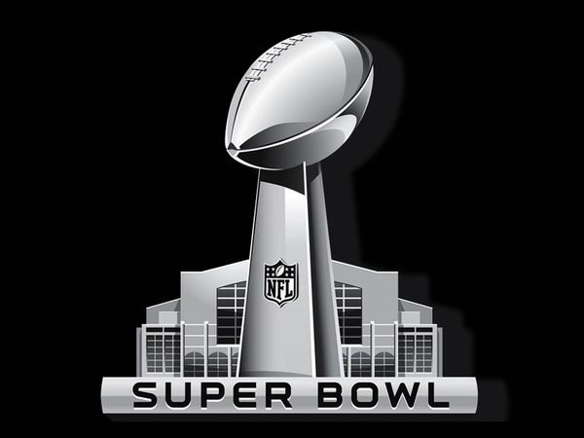
Superbowl Winners
Some teams have won the superbowl many more years than others. In this lab, you will use a dict with lists as values to determine which year(s) each team won the superbowl.
You are provided with a text file, superbowl.txt, which contains superbowl dates and winning teams, separated by semicolons. A slice might be helpful when trying to extract the year component of the date.
You should only need one pass through the data to complete this assignment.
Which teams to include? Instead of including all teams, to reduce the amount of output (and gain practice with randomness), include each team with 51.786% probability.
Below are a couple of lines of example output. Your output should look similar (but with more/different teams)
Denver Broncos won in the following years: [1998, 1999, 2016]
St. Louis Rams won in the following years: [2000]

